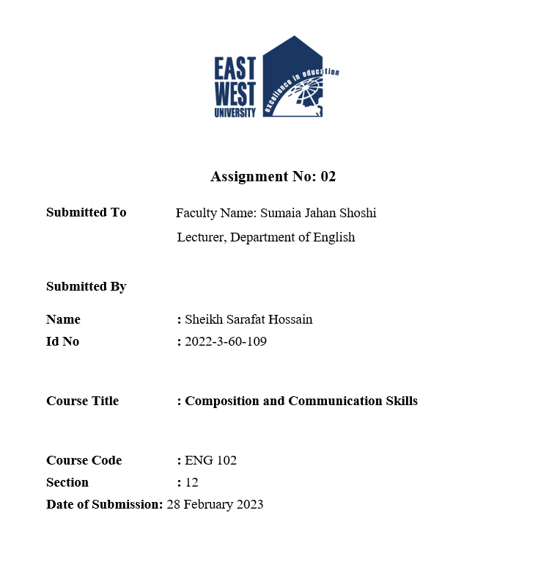



**An Exciting Experience In My Life**

**(Outline)**

**Thesis Statement:** My friends and I decided to take a vacation to Cox’s Bazar. We had been planning the trip for months and I was so excited for the chance to explore the new thing.

**Body Paragraph:**

A. Morning relaxing in the sun

B. Walk along the beach

C. Wave coming towards us.

D. Running from wave.

**Conclusion:** My trip to cox’s Bazar was full of exciting moments, but none of them compared to that wave. It was an unforgettable experience that taught me to appreciate nature's power and stay alert for the unexpected. I will cherish that experience for the rest of my life.

**An Exciting Experience In My Life**

The most exciting experience of my life happened when I was nineteen years old. After completing the HSC Examination, my friends and I decided to take a vacation to Cox’s Bazar. We had been planning the trip for months and I was so excited for the chance to explore the new thing.

It was winter. Our trip started with an exciting bus journey. The first day of our trip was the most thrilling. We arrived in Cox’s Bazar early in the morning and decided to spend the whole day nearby the beach. We spent the morning relaxing in the sun. In the afternoon, one of my friends and I decided to go for a walk along the beach. We had been walking for about five minutes when we heard a loud noise. We turned around and saw a huge wave coming towards us. It had been a while since I had seen a wave that big, and I was mesmerized. We stood there for a few seconds before realizing that the wave was going to hit us. Moreover, we both started running as fast as we could. The wave was gaining on us, and I could feel the spray of the water hitting my back. We finally reached the shore and I collapsed onto the sand. I was exhausted but incredibly exhilarated. I had never been so close to danger before, and I had never felt so alive. It was an incredible experience. The wave had been so exciting because of its sheer power.

It was a reminder of how small and insignificant we can be compared to nature. It also taught me to stay alert and to always be prepared for the unexpected. It was a thrilling experience that I will never forget.

My trip to cox’s Bazar was full of exciting moments, but none of them compared to that wave. It was an unforgettable experience that taught me to appreciate nature's power and stay alert for the unexpected. I will cherish that experience for the rest of my life.